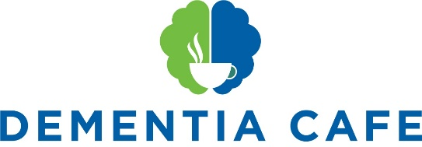

NEW Dementia Café at St Mary’s Church, Highbury Road, Bulwell, NG6 9AD
‘The Church on the Hill’
10.30am until Midday Friday 14th January 2022 (and every 2nd Friday of the month thereafter)

St Mary’s will be hosting a NEW Dementia Café, starting 10.30am Friday 14th January 2022 (and every second Friday of the month thereafter). The Café will be managed by ArtSpeak initially (part of the Radford Care Group), supported by Steve Lack (Community Health Officer, Rebalancing the Outer Estates cf. Men-in-Sheds) St. Mary’s Church and Clare Routledge from Nottingham City Council who will help with promotion and advice.

The Café will run like a coffee morning for people with a diagnosis in dementia and their carers to come along to, meet other people, chat, and enjoy some fun activities which we know will have a positive benefit on their wellbeing.

What will happen at the Dementia Café?
The National Institute for Health and Care Excellence (NICE) recommends activities such as exercise, art, gardening, baking, music, conversation and animal assisted therapy to help promote wellbeing in dementia.

We will fill the time with a mixture of activities and provide an opportunity to have discussions with carers. Our first session on Friday 14th January will be FREE OF CHARGE. Going forward there will be a small charge of £6 per person with dementia to cover the cost of the room and resources. Carers will not have to pay but are asked to stay and help support their loved one.

If you know anybody who would benefit from coming to the Dementia Café please invite them along.

What help is needed
- If you can volunteer to be there and help us run the sessions
- If you can provide any cakes, biscuits, tea, coffee sugar and milk
- If you can come and offer advice, support and or information to the people who attend
- If you have any suggestions, ideas or can find a Sponsor
- If anyone can support the Dementia Café with funding that would be good (it may be that by pulling together small amounts, we can pool resources).
- All support will be gratefully received! Please contact Fr Andrew at St Marys a.j.fisher@outlook.com 0115 975 5358

To kick start the New Year and to launch the Dementia Café we are going to screen Nottingham Playhouse’s Pantomime ‘Beauty & the Beast’ on Friday 14th January 2022. We will start at 10.30am and finish around 1pm.

The Café will be open be open to anyone with dementia with a carer. We will set up a booking system and this information will be on a flyer that we will publicise very soon – watch this space!

St Mary’s is a down to earth Christian community seeking, serving and worshipping God
by sharing the love of Jesus with all

